




Share4.0
WoRkpackage report
D3.3.1.4.2 – IMPROVE! ENDEVENT EXHIBITION

Version 1
Company – Person
Date 15.09.2022










Table of contents / Inhalt
Table of contents / Inhalt 2
1 Header 3

Workshop with target group and decision makers

"Additive Fertigungstechnologien" - Master's Degree Program
Projectpartner: FOTEC – Dr. Markus Hatzenbichler
Type: Lecture
Location: University of applied sciences Wiener Neustadt
Date: 17.03.2022

Physical/ digital demo example workshop

DIH-OST "3D Konstruktion und Simulation von Share 4.0
Projectpartner: FOTEC – Dr. Markus Hatzenbichler
Type: Workshop
Location: Teams
Date: 03.02.2022
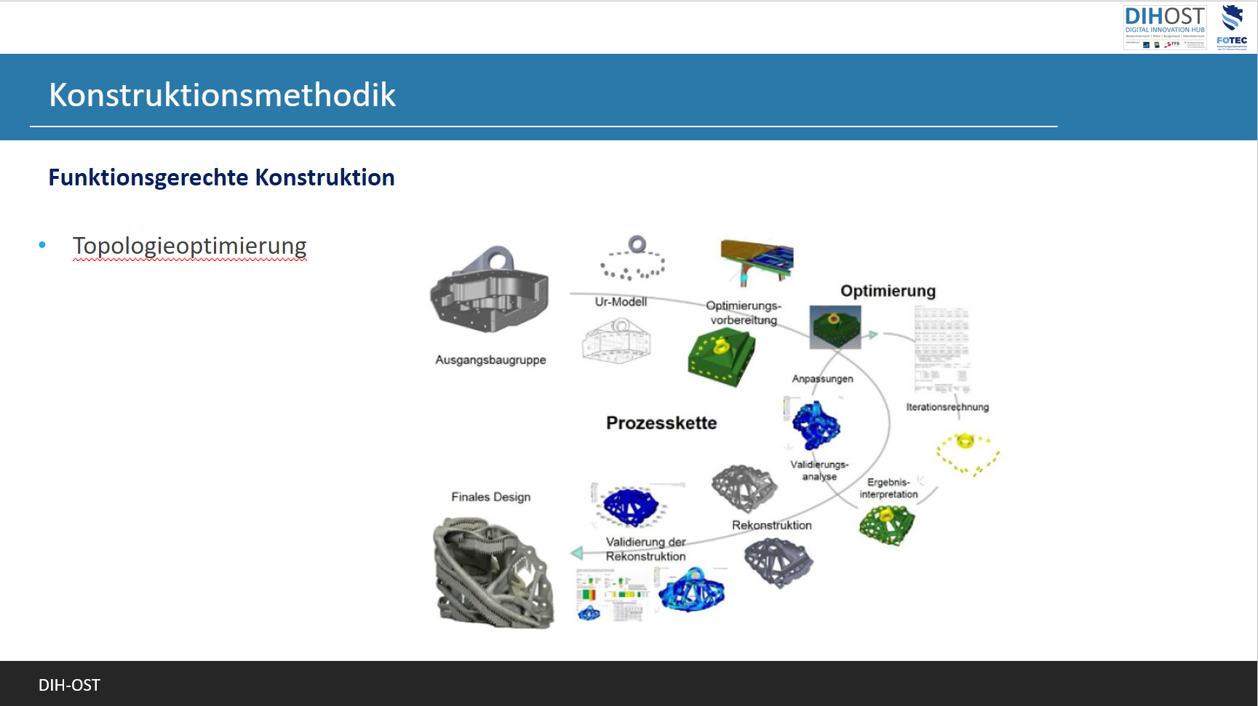

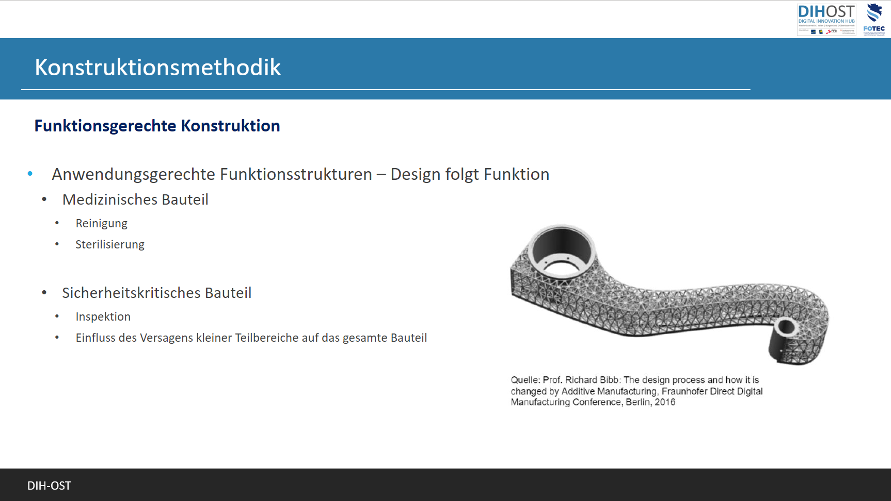

IMPROVE! Project End Event
Projectpartner: FOTEC / PROFACTOR
Type: Exhibition
Location: TFZ Wiener Neustadt
Date: 15.09.2022

Attendees

Physically

Teams
1. Zusammenfassung
Teilnehmende Teilnehmer*innen | 44
Startzeit | 15.9.22, 09:15:56
Endzeit | 15.9.22, 23:45:51
Besprechungsdauer | 14Std. 29Min. 5Sek.
Durchschnittliche Anwesenheitszeit | 2Std. 39Min. 2Sek.
2. Teilnehmer
Name | Erster Beitritt | Letztes Verlassen
Markus Hohlagschwandtner (MHo) | 15.9.22, 09:16:05 | 15.9.22, 14:55:59
Bódi Vanessza Evelin | 15.9.22, 09:30:01 | 15.9.22, 12:00:10
Lilik Gábor - VIE | 15.9.22, 09:34:12 | 15.9.22, 10:42:16
Sailer Patrizia | 15.9.22, 09:50:18 | 15.9.22, 12:45:35
Rosta György (Vendég) | 15.9.22, 09:52:21 | 15.9.22, 14:27:23
Porkoláb Gábor (Vendég) | 15.9.22, 09:54:40 | 15.9.22, 11:46:39
Bloa Bui | 15.9.22, 09:54:51 | 15.9.22, 11:40:18
Schindler Markus | 15.9.22, 09:56:25 | 15.9.22, 12:49:14
Horvath Christian | 15.9.22, 09:56:57 | 15.9.22, 14:56:11
Puchegger Markus | 15.9.22, 09:57:22 | 15.9.22, 15:03:24
Marcus (Gast) | 15.9.22, 09:57:25 | 15.9.22, 23:45:51
Klikovits Christoph | 15.9.22, 09:57:47 | 15.9.22, 13:26:26
Pichler Harald | 15.9.22, 09:58:48 | 15.9.22, 13:40:18
Medwenitsch Karina | 15.9.22, 09:59:10 | 15.9.22, 12:31:45
Gnauer Clemens | 15.9.22, 09:59:14 | 15.9.22, 14:28:34
Pllana Sabri | 15.9.22, 09:59:23 | 15.9.22, 10:09:16
Millendorfer Monika | 15.9.22, 09:59:38 | 15.9.22, 15:03:48
Knopf Silvia | 15.9.22, 09:59:47 | 15.9.22, 11:55:51
Jessica Rainprecht | 15.9.22, 09:59:50 | 15.9.22, 12:11:59
Stolavetz Christina | 15.9.22, 10:00:24 | 15.9.22, 10:29:08
Schönfeldinger Marion | 15.9.22, 10:00:40 | 15.9.22, 19:37:23
Lilik Gábor (Vendég) | 15.9.22, 10:00:54 | 15.9.22, 10:01:49
Natalie | 15.9.22, 10:00:58 | 15.9.22, 10:29:41
Prochazka Andrea | 15.9.22, 10:01:19 | 15.9.22, 12:33:30
Hauer Katharina | 15.9.22, 10:02:11 | 15.9.22, 11:15:37
Pfeiffer Christian | 15.9.22, 10:02:24 | 15.9.22, 15:03:25
Binder Johann | 15.9.22, 10:07:09 | 15.9.22, 11:26:19
Natália Kovács (Gast) | 15.9.22, 10:08:18 | 15.9.22, 12:54:02
Teresa Tschürtz | 15.9.22, 10:09:28 | 15.9.22, 12:16:31
Sophie Müller | 15.9.22, 10:09:42 | 15.9.22, 12:21:44
Hamedl Marlene | 15.9.22, 10:13:24 | 15.9.22, 11:37:08
denise | 15.9.22, 10:15:51 | 15.9.22, 10:38:16
Gáspár Júlia (Simon-Trans) (Vendég) | 15.9.22, 10:18:18 | 15.9.22, 15:34:49
Keding Marcus | 15.9.22, 10:20:18 | 15.9.22, 12:05:04
Kremsner Thomas | 15.9.22, 10:20:56 | 15.9.22, 15:00:23
Natalie | 15.9.22, 10:32:36 | 15.9.22, 11:44:10
Gyulai Tamás | 15.9.22, 10:37:45 | 15.9.22, 13:59:41
Denise | 15.9.22, 10:40:44 | 15.9.22, 11:55:48
Kerék Anikó | 15.9.22, 10:50:13 | 15.9.22, 13:32:57
Vastag Erika | 15.9.22, 10:50:32 | 15.9.22, 10:52:42
Hofmann Marcus | 15.9.22, 10:51:38 | 15.9.22, 11:28:01
Schattovits Mario | 15.9.22, 11:03:14 | 15.9.22, 11:55:34
Jennifer | 15.9.22, 11:24:14 | 15.9.22, 11:54:24
Gönczi Richárd (Vendég) | 15.9.22, 13:56:04 | 15.9.22, 15:10:55

Photo Documentation

