SUSTAINABLE, RESILLIENT USE CASES
TEMPLATE to collect USE CASES
D3.3.2.5 Sustainable, resillient use cases

Version 1

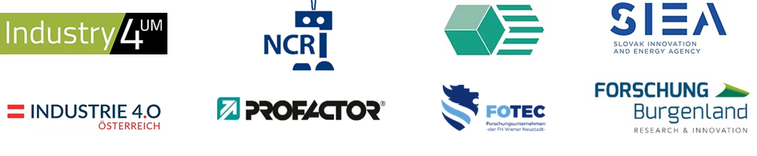

Use Case 1
TITEL OF THE USE CASE: | AMU-Bot

TOPIC: | Sustainable, resillient production systems

CONTACT INFORMATION
Partner organisation: | Fraunhofer-Institut für Produktionstechnik und Automatisierung IPA
Contact person: | M.Sc. Kevin Bregler
Address: | Nobelstr. 12  70569 Stuttgart
E-mail: | kevin.bregler@ipa.fraunhofer.de
Phone: | +49 711 970-1371

DESCRIPTION
Short summary of the Use Case:  Max.200 characters as promotional introduction | The low-cost, autonomous AMU-Bot platform mechanically controls weeds in nursery row crops. The robot detects crops using optical sensor technologies and removes all weeds from the cultivated area in line with sustainable crop protection practices without the use of chemical pesticides.
Detailed information on the Use Case:  Max.1000 characters about technical features – easy language | Until now, this has been achieved either by manual hoeing or the use of herbicides: hoeing is time-consuming, and herbicides pollute the environment with their chemical residues. They can thus become a hazard to nature, groundwater and surface waters, affecting biodiversity in neighboring ecosystems.  The AMU-Bot platform, on the other hand, removes weeds mechanically and automatically: it detects crops using optical sensor technologies and, based on this, removes the surrounding weeds using rotating tools. It can be used regardless of the crop. The platform's chain drive ensures that the field robot makes easy progress in the undefined and dynamic environment of row crops. In order to obtain project results that are as economical as possible and to ensure that the robot can be used in practice later on, sensor systems that are as cost-effective as possible are being tested.  Sponsor: German Federal Ministry of Food and Agriculture  Sponsor: Federal Agency for Agriculture and Food (BLE)
Key achievements:  Results of the application for SME e.g. new market entry | Application fields in a cross-sector context in the fields of assistance systems and resilient production;  Close-up work for the Digital Europe and Green Deal policies.
Further information:  Link to further information on the case study can be found | https://www.ipa.fraunhofer.de/de/referenzprojekte/AMU-Bot.html
Keywords related to your case study:
Visual presentation:  Image (2000px wide recommended) and/or videeo | 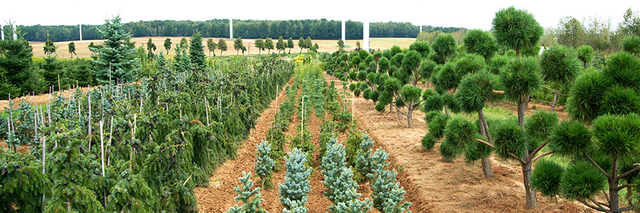
Resources needed:
Please specify the human resources required to set up and to run the case study. Do you need any external experiences to implement the case study? If yes, please specify.

