SUSTAINABLE, RESILLIENT USE CASES
D3.3.2.1.3 Sustainable, resillient use cases

Version 1
21th February 2022

Use Case 1
TITEL OF THE USE CASE: | FIBER COMPOSITES

TOPIC: | Sustainable, resillient production systems

CONTACT INFORMATION
Partner organisation: | Profactor GmbH
Contact person: | Dr. Wolfgang Heidl
Address: | Im Stadtgut D1, Steyr
E-mail: | Wolfgang.heidl@profactor.at
Phone: | +4307252 885 252

DESCRIPTION
Short summary of the Use Case:  Max.200 characters as promotional introduction | The aerospace and automotive industries rely on lightweight components made of CFRP and fiber composite materials. PROFACTOR has developed technologies that enable automatic quality control for the per se heterogeneous materials.  The fibers are characterized by different orientations and certain angles to each other. On the three-dimensional, components relevant for lightweight construction in the automotive and aerospace industries, this results in highly complex structures.
Detailed information on the Use Case:  Max.1000 characters about technical features – easy language | LScan - Inline control during the depositing process  LScan is used to perform an inline process control during depositing processes. Typical defects such as gaps, overlaps, twisted tow, and fuzz balls are detected and evaluated in real time. The sensor system is coupled directly to the laying head, so that corrections can be made immediately.  FScan - Fiber angle measurement for carbon and glass fibers  FScan is a sensor system for measuring fiber angles of carbon and glass fibers. The technology can be used for fabrics and scrims and for all intermediate steps in the production processes, from raw material to the finished, clear-coated component. In addition, the detection of typical defects (inclusions, distortions in the fabric, ...) is possible.  HScan - Inspection of holes in composite components  HScan is a sensor system for the inspection of holes in carbon fiber components or carbon fiber-metal composites. The inspection is carried out, for example, for holes for riveted joints and aims to detect process-related changes (tool wear) in good time based on the quality of the inside of the hole.  DScan - inspection of high-gloss surfaces  DScan is a sensor technology for characterizing composite components with high-gloss surfaces, such as those used for high-quality interior components. The sensor characterizes the topography of the surfaces and calculates features that have a better match with the visual impression of the surface than is the case with conventional methods (profilometer).  Translated with www.DeepL.com/Translator (free version)
Key achievements:  Results of the application for SME e.g. new market entry | The inspection system has to cope with strong reflections. PROFACTOR has developed systems with sequential illumination from different directions. Based on physical reflection models, it is possible to calculate how the fibers run.
Further information:  Link to further information on the case study can be found | (PROFACTOR)
Keywords related to your case study: | Automated quality control, zerdo defect manufacturing
Visual presentation:  Image (2000px wide recommended) and/or videeo | 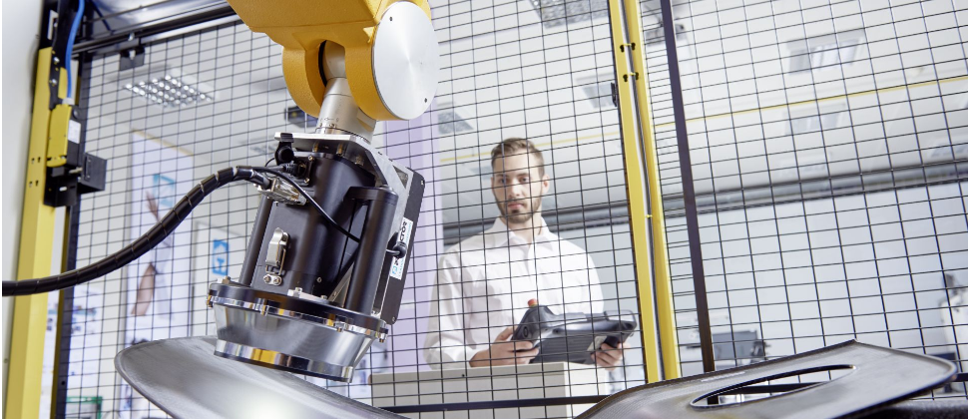
Resources needed:
Please specify the human resources required to set up and to run the case study. Do you need any external experiences to implement the case study? If yes, please specify.

