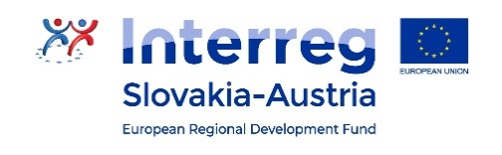
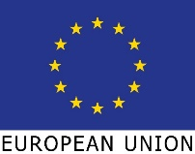

Share4.0
WoRk package report
WP3 – AT3.1 – ORganisational Handbook and Working Base, containing Rules of Procedure and Governing Model of the Smart Industry Network SK-AT

Version 2
Plattform Industrie 4.0

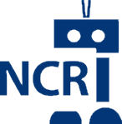
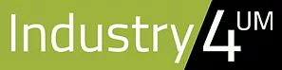
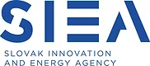
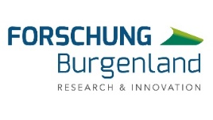
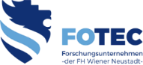
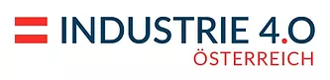

Table of Contents
Table of Contents 2
Version Control 4
Acronyms 4
List of Tables 4
List of Figures 4
1 Introduction 5
1.1 Project Background 5
1.2 Activity and Work Package Background 6
2 Background Context and Key Learnings 7
2.1 Territorial Economic and R&D Summary 7
2.2 Networks as a Tool to Steward SK-AT Coordination on Smart Industry 10
2.3 Good Practice Lessons Learnt from Transnational Networks 10
3 Methodology 15
3.1 Overall SHARE4.0 Concept Development Procedure 15
3.2 Existing Governance Components 15
3.3 Governance Model & Operational Framework Development Procedure 17
4 Governance Model 18
4.1 Establishment / Endorsement 18
4.2 Governance Structure 18
4.2.1 Executive Board 18
4.2.2 Advisory Board 19
4.2.3 Knowledge Transfer Groups & Technical Leads 20
4.2.4 Member Community 21
4.2.5 Secretariat 21
5 Stakeholder Dialogue 23
5.1 Stakeholder Engagement Definition 23
5.2 Key Stakeholder Groups 23
5.2.1 Scientific Community: 24
5.2.2 Industrial Partners: 24
5.2.3 Policy Makers: 24
5.2.4 Society/End-Users: 24
5.3 Stakeholder Dialogue Concept 25
5.3.1 Public Meetings 25
5.3.2 KTG Meetings 25
5.3.3 Regional Round-Tables 25
5.3.4 Transnational Round Tables 25
5.3.5 Other Stakeholder Engagement Processes 26
6 Organisational Processes 27
6.1 Strategy and Objective Setting and Management 27
6.1.1 Establishment of the Strategy 27
6.1.2 Ongoing Strategy/Objective Management 27
6.1.3 Change of Strategy/Objective Management 27
6.2 Knowledge Transfer Groups Formulation & Management 28
6.2.1 Establishment of Knowledge Transfer Group 28
6.2.2 Ongoing Knowledge Transfer Group Management 28
6.2.3 Change Management for the Knowledge Transfer Group 29
6.3 Action Planning and Key Performance Indicators Management 30
6.3.1 Establishment of the Action Plan and KPIs 30
6.3.2 Ongoing Action Plan / KPI Management 31
6.3.3 Change of Action Plan/KPIs 31
6.4 Communication Processes 32
6.4.1 Schedule of Network Led Meetings and Events 32
6.4.2 Schedule of Out-of-Network Meetings & Engagements 33
6.5 Additional Processes 34
7 Conclusion & Next Steps 35
7.1 Next Steps 35
8 References 36

Version Control
Version No. | Comments
1.00.00 | Base
1.00.01 | Methodology Complete

Acronyms
SIN SK-AT | Smart Industry Network Slovakia - Austria
EB | Executive Board
AB | Advisory Board
KTG | Knowledge Transfer Group
MOU | Memorandum of Understanding
PP | Project Partner
ADAS | Advanced Driver Assistance System
PESTLE | Political, Economic, Social, Technological, Legal & Environmental

List of Tables
Table 1 Quick Reference Table for the Governance Model (Source: Author Generated) 21

List of Figures
Figure 1 R&D Expenditure in % of GDP and by Sectors, by NUTS2 Regions (Spotlight on Vienna & Bratislava Region) (source: Hanzel-Weiss, 2019: 13) 8
Figure 2 Complementaries in relative functional specialisation within the Central European Manufacturing Core (average for the period of 2003 to 2015, Spotlight on Austria, Slovakia, and Germany - as a reference point) (Source: Hanzel-Weiss et al., 2018:18) 9
Figure 3 The Smile Curve - value-added creation along the production value chain (Source: Roman Stöllinger, : Vienna Institute for International Economic Studies, 2018) 9
Figure 4 Development Concept, SHARE 4.0 (Source: Author Generated) 15
Figure 5 Draft Governance Framework (Source: Author Generated) 18
Figure 7 Public Particpiation Spectrum (Source: IAP2, 2021) 24

Introduction
The purpose of this document is to represent the organisational handbook and working base, which is the conceptual output of Work Package 3, Activity 3.1 in SHARE4.0, and consolidates the organisational structure and processes, plus the governance model and ongoing stakeholder dialogue concept of the Smart Industry Network SK-AT.

Project Background
SHARE4.0 aims to improve the collaboration of key players for research and innovation through new forms of cooperation and practicable work processes. In this way, direct and long-term oriented pilot projects with high degree of effectiveness are activated and implemented. This is done based on two selected fields of work:
- Industrial assistance systems,
- Resilient, sustainable production systems.
Overall, the challenge of improving the lack of cooperation (in particular: consistency, strategy, resources, utilization, excellence) will be met by means of a high-quality bundle of service support.
As target groups, SMEs, research facilities and universities, business support organizations (tech parks, business development, etc.) and regional/local authorities will be involved in the project processing and its follow-up activities. The project processing and implementation will be carried out with all project partners in the whole program area. The planned change will be achieved mainly through the following main outcomes:
- Working base including governance model for Smart Industry Network SK-AT (Organizational Handbook);
- Two pilot projects of excellence;
- Strategy and action plan 2021-2027;
- Memorandum of Understanding.
These main results, defined as new products and services for research and innovation, provide a significant benefit for the target groups through the high degree of implementation in the project and beyond the project duration, thus making a significant contribution to an innovative, smart SK-AT region.
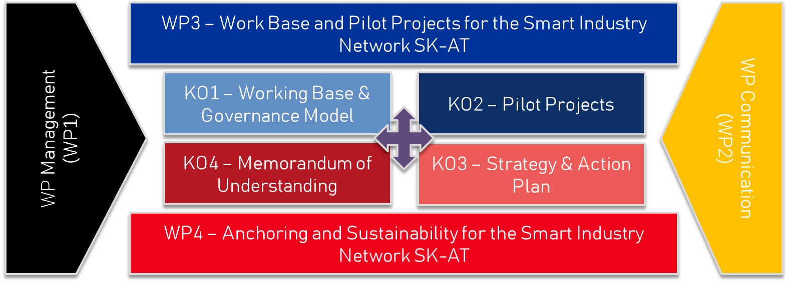
The working base and governance model sets up the key principle of the Smart Industry Network SK-AT. The Pilot Projects build in examples of the type of action cross-border cooperation can support, and the key thematic focus of Smart Industry which are of critical importance on the market, now.
The strategy and action plan, then provide a comprehensive thematic approach to Smart Industry which can be facilitated by cross-border collaboration. The Memorandum of Understanding solidifies the commitment to execute the operating model and governance scheme and to steward to completion the strategy and action plan.

Activity and Work Package Background
Creating the working base for the Smart Industry Network SK-AT, appears in the first of two thematic work packages in SHARE4.0. The aim of the third work package is to establish a permanent, usable work base for efficient and effective cooperation between key players for research and innovation, with a focus on joint working structures, processes for stakeholder involvement, measures for knowledge & technology transfer, and other key procedures to promote an optimized operating network.
Additionally, SHARE4.0’s third work package is so structured that immediate implementation of exemplary pilot projects will be kicked off in the two selected fields of work (industrial assisted systems and resilient production systems). The concept is to work on concrete, high-quality fields which can improve R&I collaboration, such as knowledge transfer for new technologies, exploitation of field-tested solutions, and use of joint research infrastructure).
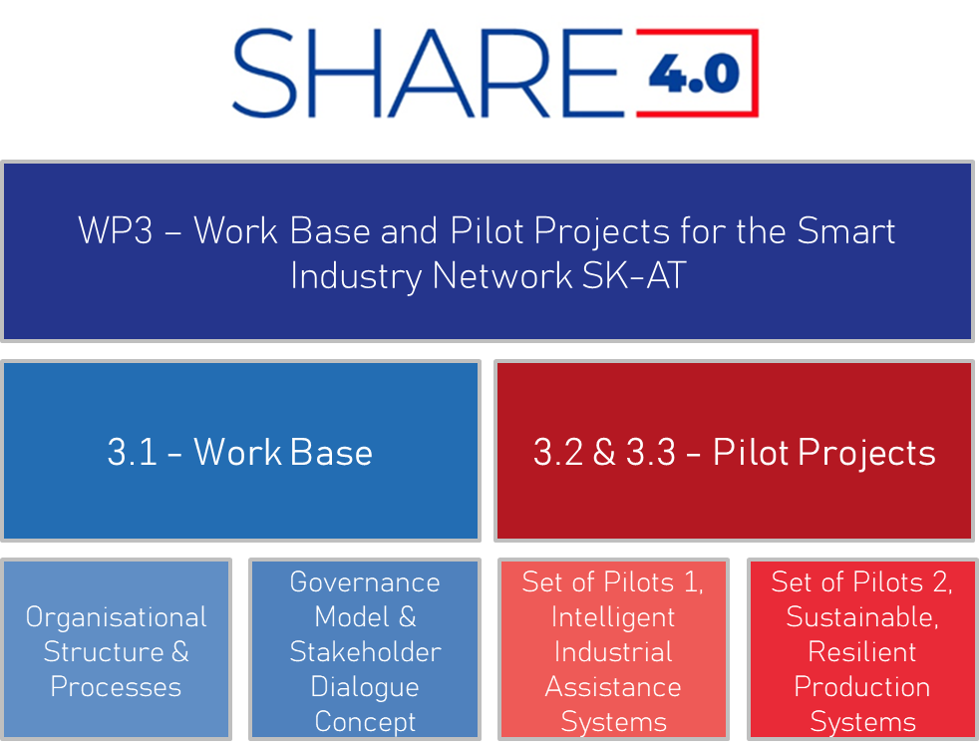

Background Context and Key Learnings
The purpose of this section is to provide some key background context, principles and learnings which are essential for developing the concept of the Smart Industry Network’s organisational and governance structure. The section starts with an economic and R&D summary, which provides market and close-to-market insights critical for understanding the potential such a network can bring. It then continues by providing summary concept and principles surrounding the use of a network as a tool to support coordination and cooperation on the subject of smart industry or the technical advancement of industry. It finishes by providing lessons learnt from good-practice networks which have been established, in more decentralised-formats, to coordinate transnational strategies that aim to promote competitive advantage in specific thematic arenas.

Territorial Economic and R&D Summary
Since 1989, diverse economic, cultural and social links have developed between Austria and Slovakia, despite the territorial area showing strong contrasting parts: there are the two capital cities, Vienna and Bratislava, with strong urban sprawl – the so called ‘Twin Cities’ , smaller cities like Trnava, St. Pölten and Eisenstadt, rural areas as well as nature protection areas along the rivers Danube and March/Morava, Neusiedl Lake and the Little Carpathians. These links have been supported and strengthened by EU-sponsored cross-border cooperation projects, as well as the close proximity of the two countries' capital cities, Vienna and Bratislava (Hanzel-Weiss, 2019). These links are strengthened in the 2020’s, through shared values and shared industrial value-chains which cross sect the border region of the two countries, especially related to the automotive sector. For the purposes of this report, the consortium leans heavily on analysis completed by the Vienna Institute for International Economic Studies from years 2017 to 2019. Specific aspects of these studies have been summarised here to provide context for key value-chains and human resources potential discussed later.
As summarised by Hanzel-Weiss (2017:23), import and export trade between the two countries has risen rapidly across the observed period (2005 to 2016), “for Austria, goods trade with Slovakia is much smaller...For Slovakia, exports to Austria are of significance in terms of both final products and intermediates. Overall, both countries can benefit from the success of one of Slovakia’s main sectors – the automotive sector – as there is a strong interdependence between the two countries, with Austria supplying car parts to Slovakia and Slovakia motor cars to Austria.'' Other areas of important connection between the two territories is associated to foreign direct investment (FDI), where Austria is the second largest foreign investor, with total of 6.2BN invested in 2015.
When looking at the two capital cities, Vienna and Bratislava – the so called 'Twin Cities' as a spotlight on employment and R&D in the manufacturing sector there are interesting observations which can be highlighted. From an employment point of view, benchmarked to 2017 data, approximately the same number of people are employed in the Vienna as in Bratislava associated to manufacturing. In Vienna four sectors account for 50% of the employed people (food, electrical equipment, repair and pharmceutical sector), whilst in Bratislava employment is concentrated in the automotive sector; the large Volkswagen Bratislava company is located in this area, right at the Austrian border (Devínska Nová Ves, close to Marchegg), as well as a range of automotive suppliers though rubber & non-metallic mineral products, basic metals & fabricated metal products, and repair are also important sectors (Hanzel-Weiss, 2019:14). Hanzel-Weiss and collagues (2018: 22-23) analyses employment and demographics of the two territories, and summarizes their findings as follows, ''A history of (mass) emigration makes the Slovak population age quickly. The working age population is expected to shrink dramatically over the next decades. Increasing wages alone won’t make a substantial change. From a current view extra-EU mass-immigration is not an option to counter labour shortages. By contrast, Vienna’s population is growing quickly. High wage levels and very high life quality indicators were important pull factors for immigration. Rapid population growth comes with high levels of unemployment, particularly among the lower educated youth. The close distance between a city with a boom in (automotive) production facilities but lack of work force and a city with a population boom but lack of jobs provides for a potential win-win situation.''
An R&D expenditure overview can be provided below for the 'Twin-Cities', for the period of 2011 to 2016, and it shows that there are some fundamental differences in expenditure as a percentage of GDP between the two regions.
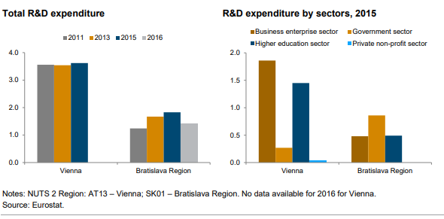
Figure 1 R&D Expenditure in % of GDP and by Sectors, by NUTS2 Regions (Spotlight on Vienna & Bratislava Region) (source: Hanzel-Weiss, 2019: 13)
Hanzel-Weiss (2017), provides some further insight on the shared economic and R&D background of the cross-border territory, ''The main items traded between Slovakia and Austria (cars versus car parts) reflect the specialisation of both economies in the automotive industry, but with a different focus: in Slovakia there are three large original equipment manufacturers – VW Bratislava (located right on the border with Austria at Marchegg), KIA Motors and PSA Peugeot-Citroën – assembling motor cars, while Austria has a large and important car parts industry...Jaguar- Land Rover (JLR) is currently building a new factory in Slovakia, where the production of initially 150,000 cars will start in late 2018. JLR will manufacture the Land Rover Discovery at its new plant located in Nitra. It is remarkable, however, that the value added of the Slovak automotive sector is still lower than that in Austria (about EUR 3 billion in Slovakia compared to 4 billion in Austria in 2016), reflecting the focus on high value added products and R&D in Austria.''
A later publication by Hanzel-Weiss and colleagues (2018), explain that much of this is because the Slovak economy can be characterised as a factory economy, with much functional specialisation in the actual physical production of goods. In Figure 2, Slovakia and Austria are compared on the relative functional specification they portrayed in a period of 2003 to 2015. Germany is also included as it portrays a classic economic 'smile' curve, which shows high specialisation in the areas of pre- and post-production where value-add is the highest (Hanzel-Weiss et al., 2018). Austria by comparison, is between these economies, with R&D and logistics specialiations. Hanzel-Weiss and colleagues (2018) conclude that Slovakia and Austria have ample space for improvement in their specialisation patterns.
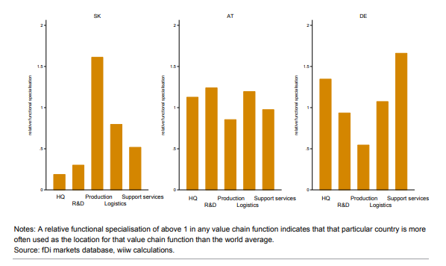
Figure 2 Complementaries in relative functional specialisation within the Central European Manufacturing Core (average for the period of 2003 to 2015, Spotlight on Austria, Slovakia, and Germany - as a reference point) (Source: Hanzel-Weiss et al., 2018:18)
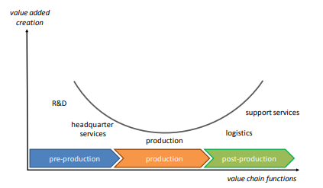
Figure 3 The Smile Curve - value-added creation along the production value chain (Source: Roman Stöllinger, : Vienna Institute for International Economic Studies, 2018)
Across both countries, but specifically in Slovakia, an effort should be made to ensure the country is not locked-in to the physical-production-oriented activity, and work to diversify towards other services in the production value chain. The knock on effects for the emerging trends in industrial digitalisation, will be felt in a more substantial way in economies that fail to diversify. Both countries, will face substantial technological changes in their production environments, and can become stronger together by working to be in a position to shape the process of industrial transformation. Therefore, it is valuable to recognize considerable economic potential in the territories, and the considerable gains which could emerge from fostering cooperation between the two territorial areas.

Networks as a Tool to Steward SK-AT Coordination on Smart Industry
Cooperation between Austria and Slovakia in the priority axes of smart cross-border regions centres on research and innovation which can be divided into two sub-targets: (1) to strengthen collaboration in the innovation system and (2) to improve higher education and lifelong learning to provide competent and skilled work forces. These aspects are necessary to build a knowledge region, which can help internal and external actors recognize the considerable economic potential in the territories, and ultimately foster the considerable gains which can emerge from cooperating in the two territorial areas. Coordination associated to industrial development (specifically industrial digitalisation) is necessary and increasing cross-border innovation networks can support this coordination and help increase the development of high-value added sectors.
Hanzel-Weiss and colleagues (2018: 22-24) also analysed this area, and provided some initial general and specific recommendations which could be used to focus the network, and promote a response to the cross-border ramifications of industrial digitalisation:
- General Recommendations:
  - Develop joint planning instruments;
  - Create a more strategic approach to technology policy;
  - Promote more cooperation within the system of universities in this territory;
  - Promote collaboration between the territory’s existing clusters & actors who have a multiplying effect in the territory.
- Specific Recommendations on Digitalisation of Industry (specifically associated to robotisation):
  - Establish a joint research centre that deals with the analysis of common solutions regarding the processes of digitalisation and robotisation;
  - Construction of a joint model factory as a laboratory of future production processes and materials (especially for the future of automotive production, such as ADAS and E-vehicles);
  - Cooperation in technology and business foresight projects to explore opportunities in other sectors, in particular high-value-added products and services that can be exported to world markets;
  - Improve connections of the territory, to the rest of the world to exploit the central position of the region within Europe, and related market for future production.
These recommendations set a nice basis for the cross-cutting themes which could be addressed by a decentralised network, spanning a cross-border arena. Decentralised (those without a common legal entity) are harder to maintain, but are beneficial at the early stages of network development because of their low-cost to operate and flexible arrangement can offer opportunities for innovation & adjustment as priorities are created for the territory.

Good Practice Lessons Learnt from Transnational Networks
SK-AT is not the first transnational territorial area which sought to establish a decentralised network to support the aligned and coordinated support in the area of Smart Industry. It is valuable to reflect on key initiatives which still operate in and around the focus-territories, so as to establish methodological and strategic links, where relevant. All the initiatives below have established governance frameworks and operating procedures around strategically-chosen, thematically relevant topics, with the purpose of cooperating to enhance mutual competitive advantage. They are also all made from a diverse stakeholder community (from public authorities, who endorse the strategy, to research organisations, companies and business support organisations, who enable the strategy).
Name of Network | Purpose of Network | Involved Regions/Territories
Vanguard Initiative | Established in 2013, the Vanguard Initiative is a unique alliance that gathers 39 of the most advanced industrial regions in Europe, focused on stimulating industrial innovation and building European value-chains based on complementarities in regional smart specialisation strategies. | Aragon, Asturias, Bozen, Trento, Baden- Wurttemberg, Basque Country, Cantabria, Catalunya, Dalarna, East & North Finland, East Netherlands, Emilia-Romagna, Flanders, Friuli Venezia Giulia, Galicia, Gavleborg, Lombardia, Lower Austria, Lower Saxony, Malopolska, Navarra, Norte, North Rhine-Westphalia, Orebro County, Pays de la Loire, Piemonte, Randstad Region, Saxony, Saxony-Anhalt, Scotland, Skane, Slovenia, South-Netherlands, Tampere Region, Varmland, Wales, Wallonia.
Danube Region | The EU Strategy for the Danube Region (EUSDR) is a macro-regional strategy adopted by the European Commission in December 2010 and endorsed by the European Council in 2011. The Strategy was jointly developed by the Commission, together with the Danube Region countries and stakeholders, in order to address common challenges together. The Strategy seeks to create synergies and coordination between existing policies and initiatives taking place across the Danube Region. | Austria, Slovakia, Czechia, Southern German (Unterfranken & Oberfranken, + all south), Slovenia, Croatia, Bosnia-Herzogovina, Serbia, Montenegro, Bulgaria, Romania, Moldova, Specific Ukrainian Regions (incl. Odessa, Zakarpattia, Ivano-Frankivsk, and Chernivtsi). Hyperlink to map
Alpine Region | EUSALP is a European strategy for the Alpine territory joining human passions, natural resources and economic assets, linking cities, plains, valleys and mountains to find solutions to challenges we can solve only together.  We coordinate planning, integrate the best practices in the fields of economy, education, environment, accessibility and mobility, and commit as institutions to create sustainable solutions for the benefits of the citizens.  By bringing governing closer to the people, EUSALP is proving that the European culture of cooperation lives. | This Strategy concerns 7 Countries, of which 5 EU Member States (Austria, France, Germany, Italy and Slovenia) and 2 non-EU countries (Liechtenstein and Switzerland), and 48 Regions.
Baltic Region | The European Union Strategy for the Baltic Sea Region (EUSBSR) is the first Macro-regional Strategy in Europe. The Strategy was approved by the European Council in 2009 following a communication from the European Commission. The Strategy is divided into three objectives, which represent the three key challenges of the Strategy: saving the sea, connecting the region and increasing prosperity. Each objective relates to a wide range of policies and has an impact on the other objectives. | The EU member states involved in the EUSBSR are Sweden, Denmark, Estonia, Finland, Germany, Latvia, Lithuania and Poland. The EUSBSR implementation is coordinated in close contact with the European Commission and all relevant stakeholders, i.e. other member states, regional and local authorities, inter-governmental and non-governmental bodies. The Strategy is also welcoming cooperation with EU neighbouring countries (Iceland and Norway).
Internationale Bodensee Konferenz | The International Lake Constance Conference (IBK) unites, as a political umbrella, the cross-border cooperation of the governments of the countries and cantons in the Lake Constance region. As a cooperative association, it serves the the Lake Constance region as an attractive place to live, natural, cultural, scientific and economic area, as well as to strengthen regional cohesion and social development. further development.  This happens in the consciousness of the coinage by common history, language, mentality and culture, in the tradition of a constructive values and principles, and with the involvement cooperation based on common values and principles and  cross-border networks. From this  understanding, the IBK promotes cross-border cooperation between many stakeholders at different levels in order to develop sustainable to work out sustainable solutions and to achieve added value for the region. In this way, IBK responsibly meets the challenges posed to the Lake Constance region by globalization, digitalization, climate change and demographic change. demographic change to the Lake Constance region. It maintains and develops, while respecting the territorial responsibilities and tasks of its members, it maintains and develops a sustainable Lake Constance region for the benefit of the community and future generations | Bavaria, Baden-Wurrtemberg, Vorarlberg, Lichtenstein, Schaffhausen, Zurich, Thurgau, St. Gallen, Ausserrhoden, Innerrhoden

Some important components of these networks are as follows:
- Strategy, with a vision and mission, which is endorsed by the EU commission or the government agencies who are operating in these territories;
- Action Plan, with clear objectives and action leaders;
- Governance Model, with clear structures established to steward the implementation of the strategy and action plan;
- Operational Model, with processes to focus on specific thematic areas, raised in the action plan + giving clear frequency and functional objectives.
- Funding, none of these networks carry a centralized budget (they all require the operational expenditure to be secured from the participating institutions/participating territories and through the acquisition of subsidy funds).
Decentralised networks are challenging to maintain, and the ones highlighted in this section have over a decade of operational experience to have formed their governance and organisational structures, their stakeholder outreach concepts and their ongoing funding concepts. Certainly, political motivation from the involved territories, appears to be a prerequisite for the success of decentralised networks. However, committed operational-level players with clear roles & responsibilities, and with motivation (especially time & cost-oriented), are the key/backbone of these networks.
Key Questions Which Need to Be Addressed By the SIN SK-AT Methodology:
- How to maintain motivation (time & cost) from the operational players?
- How to enable government-level policy making stakeholders to endorse SIN SK-AT?

A working organisational structure and governance process for the Smart Industry Network SK-AT (SIN SKAT), which can exist into perpetuity after the project finishes, is of great importance to set the key operational framework. The remaining pages of this document describes a methodology to develop the functioning structure, associated strategy, and finally the memorandum of understanding associated to the SIN-SKAT

Methodology
The methodology presented in this section provides a recommended process for developing the full & connected outputs in SHARE4.0, and then narrows-in on the specific process which will be utilised to formulate the draft governance model and operational framework, including stakeholder engagement process for the SIN SK-AT.

Overall SHARE4.0 Concept Development Procedure
It is important to re-visit the full SHARE4.0 Development Concept, as it already sets up some key structures for how a lasting network could be formulated and managed to deliver ongoing, added-value in the coordination of industrial technology development topics between the two territorial areas. In Figure 4, below, the SHARE4.0 development concept, which includes a transition image from the operating project to the ongoing existence of the SIN SK-AT.
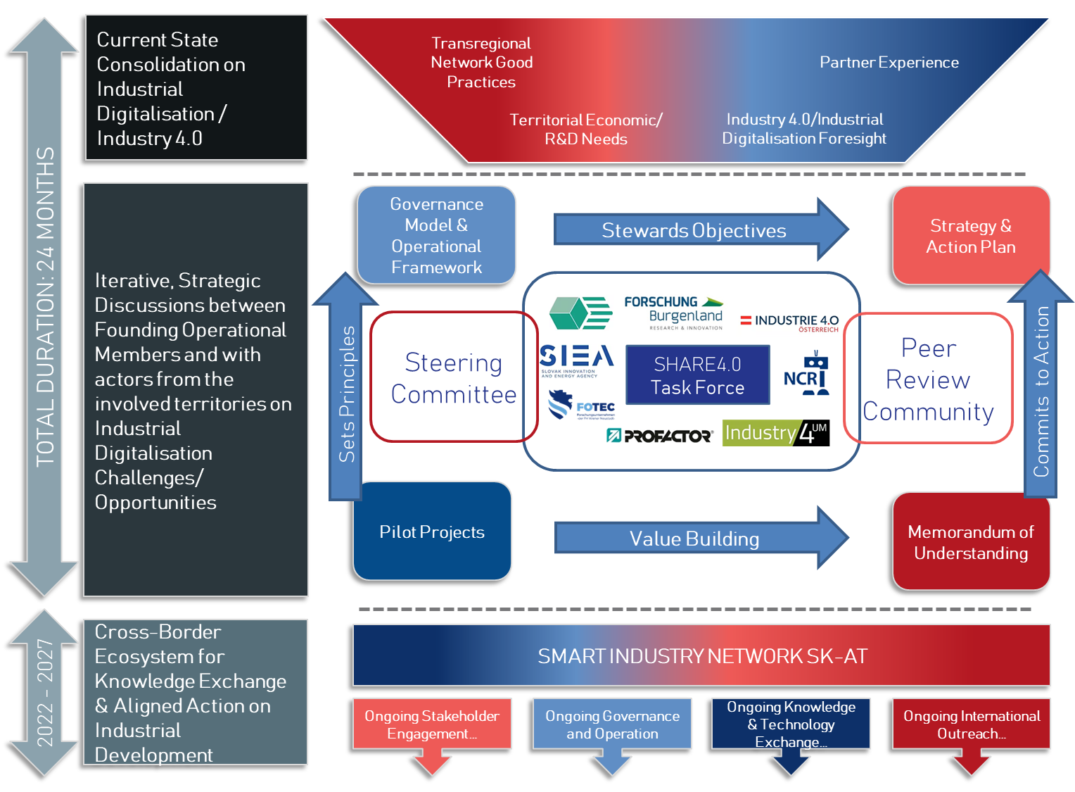
Figure 4 Development Concept, SHARE 4.0 (Source: Author Generated)

Existing Governance Components
There are five important characteristics of the current operating framework which are necessary to note as part of this methodological overview.
- The SHARE4.0 Task Force -the existing commitment made by the 8 operating partners of the project, to steward in the key project deliverables
- The SHARE4.0 Steering Committee – the existing steering committee consisting of the legal representatives of the 8 project partners (PIA, FB, SIEA, FOTEC, PRO, NACERO, UMMS, Industry4UM), and a representative from each of the 11 associated partners of the project (BMK, MHSR, Wirtschaftsagentur Wien, AIT, STU Bratislava, EIT Manufacturing East, ecoplus, BSK, TTSK, GMAR, EIT Manufacturing Hub Slovakia), who work together to steer the thematic-focus and market/territorial relevancy of the work of the project.
- The Peer Review Community – An identified group of decision makers, strategic partners, stakeholders, funding agencies, technical experts with the objective to support the project partners in the context of the development work, pilot projects and strategies in the project process.
- The Strategy & Action Plan - The Strategy and Action Plan 2021-2027 for SIN-SKAT ensures high impact in a short and long-term perspective. For efficient and effective implementation (quality and quantity), numerous stakeholders, subject matter experts and also funding agencies are integrated. In addition, cooperation with European networks of excellence (e.g. EIT/KIC Manufacturing, Vienna), digital innovation hubs and professional associations (e.g. EFFRA, European Factories of the Future Research Association) is being specifically promoted. In this way, an SK-AT or European Knowledge Alliance with a high benefit for the cooperation area is gradually emerging. The plans are also consistently clarified with all relevant funding agencies (regional, national, European) and stakeholders.
- The Memorandum of Understanding (MOU) – The Memorandum of Understanding creates a clear agreement for the SIN SK-AT. It activates the governance model & operational framework set up in this document, during the project period and is organized beyond the end of the project. It will include references to:
  - (1) the establishment and expansion of strategic collaborations for Industry 4.0,
  - (2) the targeted exploitation (capitalization) of project results,
  - (3) practicable usable mechanisms for knowledge transfer,
  - (4) the consistent implementation and updating of the strategy and action plan for 2021-2027,
  - (5) internal and external communication work (visibility), and
  - (6) learning-oriented impact controlling (peer review) for quality assurance.
All of the elements highlighted above are functionally placed to be adapted towards ongoing operating for the lasting network structure.
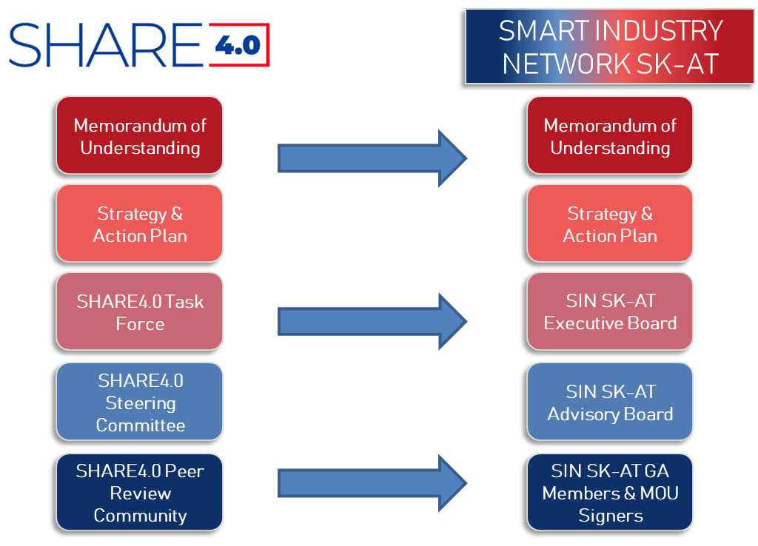

Governance Model & Operational Framework Development Procedure
In order to respect the time-sensitive nature of a project environment, it is critical that the governance model and operational framework have a development procedure which is fitting the structure of SHARE4.0. The methodology laid out below has three characteristics which are important to highlight:
- Operational Validation, by the project’s Task Force;
- Strategic Validation, by the project’s Steering Committee;
- Living-Concept, to be adapted beyond the end of the validation period – whereby the SHARE4.0 Task Force (until project end), then the SIN SK-AT Executive Board (beyond project), can make adaptations based on the development of the Strategy, Action Plan, and Memorandum of Understanding;
Stage 1- By Week 28 (Approx. Mid of July)
A draft concept for Governance & Operation is formulated, building on (1) transnational network good practices, (2) the territorial economic/R&D needs of the cross-border region of Slovakia-Austria, (3) the industry 4.0 and industrial digitalisation foresight that comes with analysing this megatrend and (4) Partner Experience, emerging from within project and out-of-project pilot initiatives which bring critical insight and long-term principles for cooperation.
Stage 2 – By Week 30 (End of July)
The SHARE4.0 Task Force, consisting of all 8 operational partners, meet to discuss and validate the governance model and operating framework.
Simultaneously, the strategy & action plan discussions begin, to set the key functional and thematic focus of the network. This process is complementary to that of the governance process (because the governance framework stewards and enables the strategy and action plan).
Stage 3 – By Week 33/35 (Mid / End of August)
The SHARE4.0 Steering Committee, consisting of the operational partners and the associated partners, meet to discuss and validate the governance model and operating framework. At this point the Governance Model and Operational Framework are adopted, and exist as a living concept, whilst the other Outputs are being developed.
Simultaneously, Strategy & Action Planning discussions continue, and the draft Memorandum of Understanding is presented.
Stage 4- till Week 47 (End of November)
Governance Model and Operational Framework is open for adaptation, whilst the strategy & action plan and MoU are being presented and revised through the Peer Review Community Workshops.
In the remaining pages of this document, the draft governance model is presented.

Governance Model
SIN SK-AT is designed, at the outset, as a decentralised innovation network without a formal legal-entity. The governance model of SIN SK-AT has been designed to reflect the autonomy of the two territories (SK & AT), the interest-level of the involved participants, the nature of a decentralized network without any immediate legal-entity to take over management responsibility.

Establishment / Endorsement
SIN SK-AT needs to be established and endorsed to operate. The recommendation from this author, and the logic of the SHARE4.0 project is that the presentation and first signatures on the Memorandum of Understanding, should set the first establishment of the SIN SK-AT Network.
Furthermore, we would recommend as either part of the MoU, or separate as a communication effort of the project, a joint statement from the high-level decision makers involved in the project & from the participating territories, surrounding the need and purpose for such a network’s establishment. This would be a one-off statement, which could be drafted in German & Slovakian, and signed by the participating regional and national governments (AT: Burgenland, Wien and Lower Austria; SK: Trnava and Bratislava). The issuing of this statement, and the MoU can become the formal founding date of the network, and the signatories on the MoU become the founding

Governance Structure
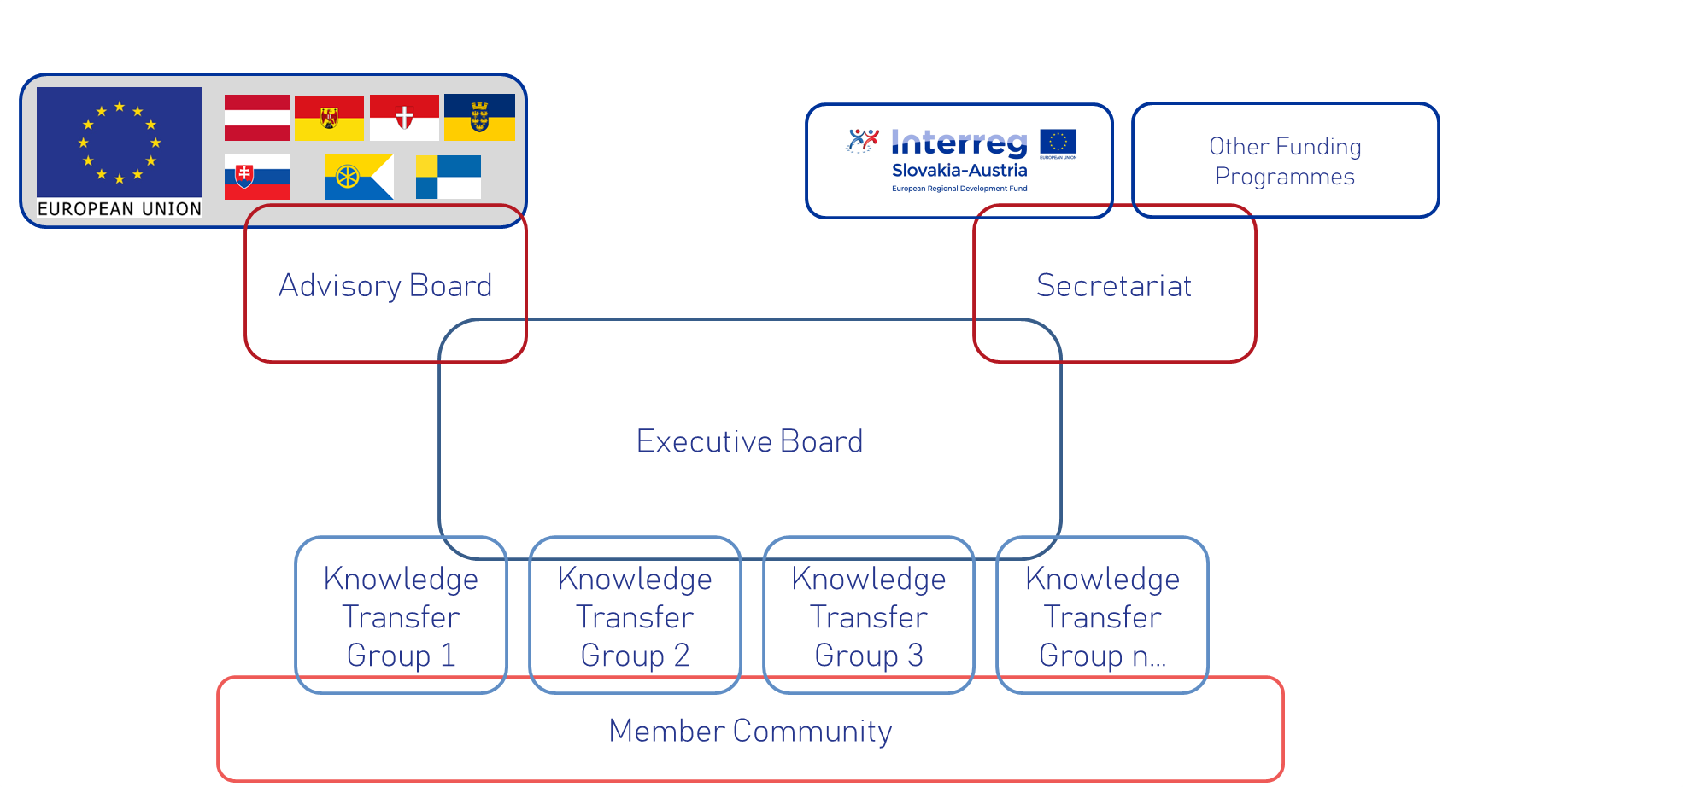
Figure 5 Draft Governance Framework (Source: Author Generated)

Executive Board
The Executive Board (EB) is the central decision-making body of the SIN SK-AT. At the network’s inception, the composition of the Board consists of all of the SHARE4.0 project partners. In every subsequent year of the network’s existence, the EB will be voted on by all members of the network, during the General Assembly (discussed in the next section). The composition of the EB at the start of the network, will consist of 8 members, with 1 member nominated to the status of Chair. The Chair will switch between an Austrian and Slovakian organisation each year.
The EB meets quarterly (four times per year), and are formally responsible for the following items within the governance framework of the network:
- Changes to the MoU,
- Changes to the operating Strategy or Governance Model,
- Establishing (or disbanding) Expert Groups.
Regarding voting rules, each member of the EB has one vote. Issues will be voted on seeking a simple majority. In case of a tie (which is feasible with 8 members), the Chair will issue a tie-breaking vote.

Advisory Board
The Advisory Board at the start should consists of the Associated Partners of SHARE4.0. These organisations will nominate an individual to sit as a permanent advisory to the Executive Board and the SIN SK-AT. To be certain of the appropriate composition, the Associated Partners of SHARE4.0 should be approached during the MoU signature phase, to set their name against this specific role at the time of signature, including:
- BMK,
- MHSR,
- Wirtschaftsagentur Wien,
- AIT,
- STU Bratislava,
- EIT Manufacturing East,
- ecoplus,
- BSK,
- TTSK,
- GMAR,
- EIT Manufacturing Hub Slovakia.
It would be recommended that a representative from the region of Burgenland also join the Advisory Board, to ensure all territories involved in the network are represented at the inception of the network.
The Advisory Board is asked to meet once per year, and on an ad-hoc basis if need arises. These meetings can be virtual, if relevant.
The Advisory Board’s remit is to provide external perspectives on emerging opportunities and pressures which could impact the network, from a political, economic, social, technological, legal and environmental point of view. The PESTLE framework-of the territorial area will be analysed each year by the members of the Advisory Board, during which key insights will be taken up by the Executive Board, to action within the network, if necessary.
The Advisory Board composition can shift depending on the needs of the EB during the life-time of the network. It may be beneficial to add specific technical advisors depending on the nature of subject matter being discussed or the challenges faced by members of the network. The Advisory Board will be chaired by the Chair of the Executive Board, who is required to fulfil both moderation positions.

Knowledge Transfer Groups & Technical Leads
The Knowledge Transfer Groups (KTGs) are the location for technical and thematic discussions within the Network. The KTG structure has been a tested method, and good practice from other thematic networks which have been observed.
The KTG’s goal within the governance of the network is to steward the actions of the Network (specifically those actions which emerge from the Action Plan, and strategic objectives of the SIN SK-AT). In fact, every KTG is required to have an Action Plan as part of its formalization. The Executive Board votes to formalize the existence of any new KTG, and monitors if the KTG has created their Action Plan & monitors Action Plan development.
The KTG are recommended to be led by a Technical Lead (TL), who is the individual formally responsible for providing updates on the running activities and exchange within the KTG. Technical Leads are chosen at the inception of the KTG. TLs arrange meetings for the KTG, with the support of the group members, and the TL is responsible for creating session minutes.
Each KTG must, as a minimum, meet twice a year, and must keep a standing record of the organisations who are formal participants in the Group (from the standing membership pool of the Network), and who are external experts or other interested stakeholders who join KTG meetings. Meetings can have an open & a closed portion to allow formal management conversations to occur at the same meeting event as the technical discussions.
It is recommended that the total number of KTGs which should be in existence at the outset of the SIN SK-AT is kept to a minimum to keep the thematic discussions & network operation manageable. Naturally building from the thematic focus of SHARE4.0, it would be recommended that three topics are the starting focus:
- Industrial assistance systems
- Resilient, sustainable production systems
- International collaborative systems for industrial development;
The first two are the core thematic focus determined at the founding of the SHARE4.0 project, and should be tested with the Task Force for their relevancy after the creation of the Strategy and Action Plan. The third subject is a cross-cutting initiative which provides a unit of KTGs to specifically talk about international methods for collaboration in industrial development, this KTG stewards the international outreach activities of the network.

Member Community
The Member Community is the base of the network. Membership is agreed when an organisation signs up to the terms of the Memorandum of Understanding. There will be two categories of members, at the start of the network’s existence: Core Members & Observing Members
Rights of Core Members in the community is to:
- Participate in the annual General Assembly, and vote on the Executive Board of the network;
- Participate in an KTG;
- Be eligible to be chosen as a Technical Lead for an KTG.
In order to be considered a core member, you must represent an organisation or legal entity with an active interest in Slovakia and Austria, and therefore have a legal representative or delegated representative who can vote in the annual General Assembly.
Rights of Observing Members in the community is to:
- Participate in the annual General Assembly, with no voting rights;
- Participate in an KTG.
There are no obligations associated to the role of Observing Member. All individuals and all organisations may be observing members of the network.

Table 1 below provides a quick reference to all the governance aspects which have been so far described.
Table 1 Quick Reference Table for the Governance Model (Source: Author Generated)
Name of Component | Acronym | Summary Purpose | Meeting Schedule
Executive Board | EB | The central decision-making body of the SIN SK-AT. Votes on changes to the governance model, the MoU, the Strategy, and establishing (or disbanding) KTGs. | 2/ year,
Chairman of the EB | Chair | The annually-chosen, responsible individual who manages the EB. Changes between an AT & SK representative each year. Chairs all meetings, brings aspects to a vote, and holds the tie breaking vote on any relevant issue in the EB. | 2/ year + adhoc
Advisory Board | AB | The support entity which provides key external perspectives on (opportunities and threats) which might influence or impact upon the network. | 1/ year
Knowledge Transfer Groups | KTG | Thematic / technical exchange-oriented working group, centralized around a specific topic, with a cohesive action plan which is used to steward activities within the network associated to that topic. | 1/ year
Technical Lead | TL | Leads the EG, ensures meeting schedule is executed and exchange occurs on the EG topic | 1/ year + adhoc
Member Community | MC | The base community of participants who sign the MoU and are eligible for voting at the GA & operating in the KTGs. | 1/ year

Stakeholder Dialogue
Stakeholder dialogue is a critical component of any successful innovation network. It allows the network to ensure it is not insular in its focus, and brings a level of 360 Degree-Feedback which is essential for development. Following on from the governance model, a comprehensive stakeholder dialogue concept is described for the SIN SK-AT.

Stakeholder Engagement Definition
There are many definitions of what stakeholder engagement and stakeholder dialogue can mean. In Figure 5, a simple depiction of different stakeholder engagement levels is presented, moving from ‘inform’ to ‘empower’, with stages between dictating the amount of total participation which is expected from the stakeholder, and most important the commitment that is made to the public at large by the network in question. In SIN SK-AT we aim to incorporate different aspects of public participation encouraging quadruple-helix engagement with the topic of Smart Industry. Therefore, different mechanisms are built into the standing processes of the SIN SK-AT to build relationships with key stakeholder groups.
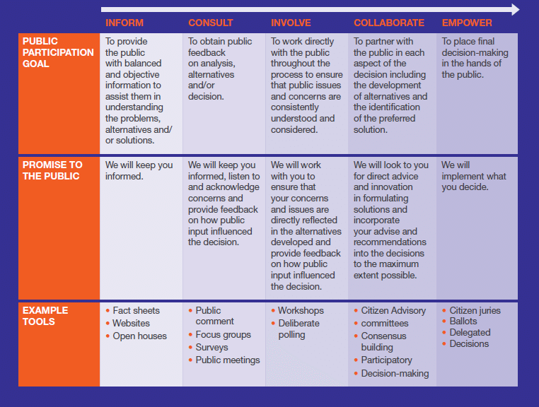
Figure 6 Public Particpiation Spectrum (Source: IAP2, 2021)

Key Stakeholder Groups
It is important to explicitly describe the stakeholders who are addressed by the SIN SK-AT. As mentioned above, taking a quadruple-helix approach, and addressing the scientific, industrial, policy making community, as well as citizens of the territory, is at the cutting edge of participatory engagement methodologies. In the context of the SK-AT cross-border territory, this refers to:

Scientific Community:
Research centers, universities, universities of applied sciences interested in progressing smart industry-oriented research. There are a significant amount of these institutions in the cross-border area of SK-AT, which are working on relevant research which can support industrial digitalization and development.

Industrial Partners:
Companies and industrial stakeholder can be identified across the entire industrial value chain in many sectors which are present in the territory, such as automotive, petroleum/petroleum products, food/agricultural, electrical equipment, repair and pharmceutical sector. Cross-value chain representation can address: (A) Material Providers; (B) Equipment Providers/Tool Vendors (C) Manufacturers (D) Fabless enterprises (SME & LE), companies innovating designs but without production equipment (E) Service Sector companies who deliver consulting, financial, legal and other support to the main industrial sectors, and many others.

Policy Makers:
Addressing those policy makers at local, regional, national level who have an interest in industrial development, and the coexistence of this in the cross-territorial area. Those policy makers at EU-level could also be addressed, who are working on strategies and legislation associated to the security of supply, resilience and leadership in European industrial development, and other initiatives to promote democratization and utilization of technology as part of the Digital Decade strategy.

Society/End-Users:
Addressing consumers of industrial products, also as concerned citizens who maybe be interested in industrial digitalization and the impact of this on their communities. It could also address students and youth who may be growing up in this territorial area and want to understand the future potential of this region for their career development.

Stakeholder Dialogue Concept
To address these target groups/ stakeholders, the following stakeholder dialogue events and initiatives are recommended to be spearheaded by the SIN SK-AT network to foster the aforementioned engagement (gain feedback from, work directly with, and also delegate to organisations and individual representatitives from these communities)

Public Meetings
The public will be invited to join specific meetings from the network. It is not always appropriate for the public to be involved in every meeting, however in order to gain insights from individuals and organisations which may not already be part of stakeholder dialogue, public meetings act as a good forum for a mix of unstructured and structured exchanges.
The General Assembly, which will be further described in the next section, is a good example of such an event which will be open to public registration and attendance for all aspects of the quadruple-helix. Other town-halls and engagement events will emerge as the network develops.

KTG Meetings
KTGs will be comprised of core members, observing members, and special guests who are relevant for the specific discussions. Meetings of the KTGs (minimum twice a year), will include all of these individuals. Guests can come from within the territorial area, or external to the territorial area, depending on what subject is being discussed.
The KTGs are a good location for thematically-oriented dialogue with a mixed stakeholder base (primarily Academia & Businesses), to promote higher-levels of involvement and sets up real-life collaboration and innovation opportunities, along with sharing good-practice and lessons learnt. These are ultimately designed to empower organisations to work together to overcome mutually agreed upon challenges and build mutual-competitive-advantage in the cross-border arena.

Regional Round-Tables
The regional round-tables are a recommended mechanism to engage the public administration, and more policy-oriented partners. The concept would be that the executive board, during an extended session of their own quarterly meeting, invites the regional and territorial representatives (many of whom are in the AB), to join a specific discussion on socio-economic and socio-political developments which are relevant for influencing the strategic orientations of the network’s operations. The EB will organise and moderate the regional round tables on behalf of the network. It is recommended that the location of the regional round-table moves between the different territorial areas represented (Lower Austria, Trnava, Bratislava, Vienna, Burgenland), throughout the years of the network’s operation.

Transnational Round Tables
The transnational round-tables are a recommended mechanism to ensure you have external views brought into the territory. The concept would be that the executive board, during an extended session of their own quarterly meeting, invites extra-territorial organisations (from across the triple-helix) to join the discussion on strategic issues associated to the network. These can be organisations who have experience in running other strategic networks, or organisations who have specific insights on EU-level developments which are of interest to the operational health and wellbeing of the network.

Other Stakeholder Engagement Processes
It is understood that at the early stage of network-development, there may not be a significant amount of resources available to develop the full stakeholder dialogue concept

Industrial Focus Groups
Based on the purpose of the network, and the issue at the crux of the network’s development – building a smart and resilience industrial eco-system in the cross-border area, industrial focus groups could be a useful tool deployed by the KTGs as a way of enhancing stakeholder dialogue with enterprises.
Establishing Industrial or even sector-specific or value-chain specific focus groups within the wider thematic arena covered by the KTG can give better targeted support. These can become tools for academia, business support organisations, and other businesses to learn about perspectives and needs for industry actors in the territory.

Bilateral, Quadruple-Helix, Interviews
In a similar vain to the industrial focus groups (which are ultimately multi-lateral semi-structured interviews), bilateral semi-structured interviews of different actors representing the quadruple-helix could also be an advantageous asset to the Stakeholder Dialogue concept of SIN SK-AT as it develops.
These interviews can be with companies, researchers, policy-makers, and of course students and the general public who can help represent civil society within the context of quadruple helix engagement.

Organisational Processes
It is now important to pivot to the organisational processes and content working-base which will be stewarded by the aforementioned governance model. The purpose of this section will be to describe these organisational processes and organisation base. It starts with setting key links to establishing the objectives & key goals of the network, then moves to the Key Performance Indicators (KPIs) and the formulation of the KTGs. The section finishes with a description of the key schedule of events and meetings.

Strategy and Objective Setting and Management
The strategic aim and base goals of the SIN SK-AT need to be established, and ongoingly managed, in order to ensure an effective operating remit.

Establishment of the Strategy
The formulation of the strategy and objectives occurs in the execution of WP4 in SHARE4.0, and will be validated by the network participates through the first signature on the MoU.
It is recommended that the strategy and objectives of the network are linked to the gaps, insights, future foresight and experience of the founding members of the network and their stakeholder community. Insights can also be gained from analysis of the economic and R&D potential of the cross-territorial area; many of which were provided in the background & context section of this document. Some concepts which this author would recommend being at the heart of the developed strategy:
- Promoting cooperation to support the development of a vibrant cross-border knowledge-community on industrial development and industrial digitalisation;
- Creating a space to share knowledge and experience, within defined network topic;
- Generating an environment for identifying new, cutting-edge topics which can provide industrial opportunities or must be addressed to mitigate threats;
- Encouraging collaborative environments to promote joint development of project proposals or to kick-off new projects together.

Ongoing Strategy/Objective Management
The ongoing management of the strategy will be the responsibility of the Executive Board, who are given the obligation of stewarding the strategy to its achievement. The Executive Board provides yearly updates associated to the progress of achieving or stewarding the strategy at every General Assembly.

Change of Strategy/Objective Management
Changes to the strategy and associated objectives can occur during the sitting of the Executive Board meeting (quarterly). Standard voting procedures are recommended for making amendments to the Strategy and Objectives.

Knowledge Transfer Groups Formulation & Management
The thematic-orientation of the network, which occurs via the Knowledge Transfer Groups (KTGs) must be established and ongoingly managed in order to ensure the appropriate development scope associated to Smart Industry is fostered by the participating organisations.

Establishment of Knowledge Transfer Group
Establishment of the initial KTGs happens within the validation process of this governance document, which occurs through the signing of the MoU at the end of SHARE4.0.
As previously expressed, it is recommended that the core topics of SHARE4.0 are adopted as the first two thematic groups, plus a third group on international systems for collaboration (a more thematically open group, which allows methodological exchange between the two territories):
- Industrial assistance systems,
- Resilient, sustainable production systems,
- International collaborative systems for industrial development.
The Technical Leader will also be chosen at the same time as the establishment of the KTG.

Ongoing Knowledge Transfer Group Management
Ongoing management of the KTG will happen by the Technical Leader. The TL manages membership to the KTG, and the agenda and invite list to KTG meetings. Two mandatory meetings are required each year for the KTG to be considered relevant. Only registered network members can join KTG Meetings. However, members of the KTG can recommend special invites, if relevant for a specific discussion purpose.
Within the two mandatory meetings, a set, half-day agenda, is recommended which relates to:
- Each member provides a 10-minute update on key developments, which are of relevance to the network (cutting edge topics, their new activities, their pitches about potential projects);
- a review of the Action Plan and;
- a risks & opportunities review amongst the standing members of the KTG.
- Open discussion to pick up points raised from member presentation & risk/opportunity review.
Other agenda points, are up to the discretion of the TL to set, in cooperation with the standing members of the KTG.
The TL provides a six-monthly Status Report, to summarize the development associated to the KTG Action Plan (what has occurred, what have pinch-points been, where are they going). and creates a recommendation list on what strategic support is required to enhance KTG activity. It is also during this six-monthly report where the TL is asked to provide a recommendation on the ‘fit-for-purpose-ness’ of the KTG. It is important that the SIN SK-AT stays thematically relevant to support real issues of industrial development, not to run a thematic working-group for the sake of it. Therefore, the recommendation from the TL is of high-importance for setting up the operational support for the KTG.
The KTGs are overseen by the Executive Board during the standing meetings of the Board, with the Status-Reports delivered twice per year (once at the end of Q1 and once at end of Q3, in advance of the GA). Additionally, The TL role is validated yearly by the Executive Board, who assess if the KTG and the TL have an appropriate operational fit with the strategic orientation of SIN-SKAT. There are no term limits or territory-switch requirements for the TLs.

Change Management for the Knowledge Transfer Group
Change management associated to the KTG can come from changes to membership and changes to the existence of the KTG altogether. Changes to the Action Plan will be discussed in the next section
- Changes to membership is managed by the KTG TL;
- Changes to the existence (i.e. creating or dismantling) of KTGs is managed by the Executive Board on an annual basis, upon the functional review of the Status-Report.

Action Planning and Key Performance Indicators Management
The establishment, management and change control of the Action Plans is a key functional process which is essential for the transparent operation of SIN SK-AT. These working documents are of critical importance for fulfilling the strategic orientation of SIN SK-AT, and are used to steward the actors in the network towards common goals.
The concept of establishing and managing Key Performance Indicators (KPIs) is also relevant, in this regard, as KPIs will provide the metrics which can be used to show growth & development associated to cross-border collaboration.

Establishment of the Action Plan and KPIs
The KTG Action Plan(s) are formulated in the execution of WP4 in SHARE4.0, and will be validated by the network participates through the first signature on the MoU.
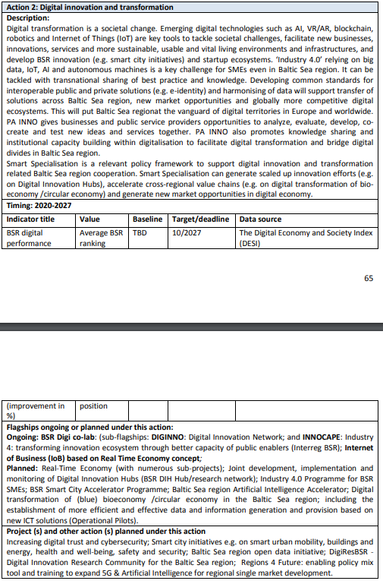
It is recommended that the Action Plan are linked to realistic goals or Key Performance Indicators (KPIs) set by the participating partners, and represent tangible actions which can help further a coordinated and collaborative approach to knowledge exchange and innovative activity development. It is also recommended that the KPIs establishment occur in the execution of WP4’s Action Planning, and becomes and agreed principle for the base of how each Action is planned. Figure 7 provides an excerpt from the Baltic Sea Region (BSR) programme, and provides an image of an action planning process which includes KPIs for long-term management. Also, interestingly, provides an opportunity to showcase flagship operations, projects and other actions which are being planned to meet the action description.
KPIs should be reflective of measurable areas of assessment, and can be both macro & micro in their orientation, associated to innovation, network and industrial development. They should be set for a manageable period of time, ideally from 2022 to 2025, at their starting point.
Figure 7 Action Plan Excerpt, Baltic Sea Region (Source: BSR Action Plan, 2021)
Some recommended KPIs which could be considered during the establishment process is the:
- Attractiveness of research system (Improvement %),
- Attractiveness of territorial area for business (Improvement %),
- Firm Investment in R&I (Improvement %),
- Research Infrastructure Investment (general) (Improvement %),
- Total Number of Innovators (Improvement %),
- Total Number of Contractual Linkages Evidenced (Improvement %),
- Total Number of Mobilities Executed (Study Visits, R&I ecosystem tours, etc) (Improvement %),
- Total Number of Exchanged Peoples between institutions in the territorial eco-system (Improvement %),
- Total use of cross-border R&I infrastructure, by organisations outside of the specific territory (Improvement %).
There are numerous other KPIs which could be brought into the network’s stewardship; however, it is always a matter of network resources to effectively monitor this performance. It is valuable to look to other networks to see and be inspired about how the commitments have been formalized for long-term planning and action.
Other interesting characteristics from the BSR action planning is clarifiying:
- Strategic objective of the topic area;
- Linked Sustainable Development Goal, to give a global connection to the work;
- The Related EU and other Policy Frameworks which are connected to the action (and a statement of how connection to these policies will be established);
- The stakeholder involvement plan for the designed subject area;
- Key policy achievements.

Ongoing Action Plan / KPI Management
The ongoing management of the action plans is delegated to the Technical Lead of the Knowledge Transfer Groups (KTGs). Each KTG is asked to have an action plan, so there is a clear operating remit expected from the network.
Every Action Plan status must be presented twice a year. Two status reports will be produced. Both reports will be produced with an audience of the Executive Board, with recommendations on any update or change which should be made to the plan. Status update 1, should be produced by the end of the 1st Quarter (End of March). Status update 2, should be produced by the end of the 3rd Quarter (End of September). Please note: No status reports are produced for the General Assembly, a general summary of KTG successes can be presented

Change of Action Plan/KPIs
Change to the Action Plan should be validated by the Executive Board, upon delivery of the Status Report. The TL of the KTG is responsible for consolidating recommendations for change within this report (including, if relevant, the suspension or disintegration of the entire Action Plan & KTG).

Communication Processes
It is important to highlight the communication processes of the network, as these are the functional core of its operation. The EB is responsible for arranging & stewarding the network led meetings & events

Schedule of Network Led Meetings and Events

General Assembly
The General Assembly is the terminology used to describe the meeting of all the members of the SIN SK-AT network. The GA is an annual meeting, where a Network Status update is given and the Executive Board is voted on by all signatories of the MoU. The GA happens in the last quarter of the year, and sets up the strategic operation for the following year.
The GA is open to all stakeholders, but only Core Member signatories on the MoU may vote as part of the network’s governance model.
The GA operates as a full-day event, with open & closed meetings of the Executive Board, the Advisory Board, and the KTGs.
During the event proceedings the following activities are recommended as fixed additions:
- Presentation on the Status of the Network,
- Presentation of the Action Plans & Status Report of the KTG,
- Voting on any Amendments (non-membership orientated) to the MOU,
- General Assembly vote on releasing the Executive Board,
- General Assembly vote on the new Executive Board.
For all voting orientated sections of the meeting, it is recommended that a 2/3 majority is established among the voting members. It is also important that at least half of the signed members of the network are present to create a quorum for the vote to take place. Voting options will always be: ‘yes’, ‘no’, or ‘abstention’.
Additionally, it could be valuable to use the same meeting to have a:
- Meeting of the advisory board,
- Meeting of the new executive board,
- Meetings of the KTGs,
- Meeting of the Regional and Transnational Round-Table.

Meeting of the Executive Board
One thing that it is important to note, is that the standing meeting of the Executive Board will occur quarterly. These meetings should be closed-meetings, and offer an opportunity to take appropriate management decisions necessary to keep the strategic objectives of the network on track. As previously explained, the EB will arrange this meeting, and it will be chaired by the selected individual who has the year-long chair of the Executive Board.

Meeting of the Advisory Board
The Advisory Board, as previously explained, will be required to meet once per year, and on an ad-hoc basis after this point (if the need arises for specific advice or further support). The Advisory Board meeting is recommended to occur as a closed session, during the General Assembly to ensure the highest level of efficiency for this meeting & the required attendance.
The EB will arrange the meeting and invitations – and the meeting will be chaired by the chair of the Executive Board (who will hold both moderation positions).

Meeting of the Knowledge Transfer Groups
The Knowledge Transfer Groups must meet as a minimum twice per year. The Technical Lead (TL) will be responsible for scheduling, inviting and moderating their designated KTG.

Schedule of Out-of-Network Meetings & Engagements
The EB will manage these meetings, scheduling & attending, but all members of the executive board will be asked to contribute with network meetings to spread the word about SIN SK-AT’s good practices, successes, and opportunities.

Engagement Meeting with other EU Networks
As we’ve demonstrated through the document, learning and exchanging with other EU Networks will be highly advantageous for SIN SK-AT. EU operating networks can provide useful insight on operational processes, as well as providing important territorial and market support from transnational engagement. It is recommended that the EB profile a shortlist of EU Networks which are of both geographic and market-interest.
A starting list of the networks which are relevant in this regard are as follows:
- Vanguard,
- EUSALP,
- EUSDR,
- EUSBSR.

Engagement Meetings with International Organisations & EU Agencies (EIT)
International Organisations and EU agencies are useful partners for understanding regulatory changes and subsidy opportunities. Plus, organisations such as EIT, can provide useful R&I development-oriented insights which keeps the network connected to cutting-edge interest areas for industrial digitalisation.

Engagement Meetings with National, Regional and Local Agencies (BMWA)
Based on the territorial scope of SIN SK-AT, keeping an open dialogue with national, regional and local agencies can be advantageous to the network. It is especially important to engage with individuals who are outside of the organisations identified as part of the Advisory Board.

Additional Processes
Depending on the decision of the Executive Board regarding the development path of SIN SK-AT, there are other processes which are important to clarify within the first one to two years of the network’s operation. This list is not conclusive, but it is key to consider:
- Financial/Resource Planning, especially with regards to:
  - the creation and execution of an operating plan (cost-side) including necessary resources to run the network;
  - The creation of revenue stream(s) from member fees and industry donations;
  - The generation and execution of a subsidy acquisition process.
- Legal Planning, especially with regards to the formalization of the network as its own legal entity and the ramifications which must be followed in this regard.

Conclusion & Next Steps
The purpose of this document has been to establish the fundamental rules of procedure for the governance of the Smart Industry Network Slovakia-Austria. As part of this purpose, the document has provided a governance model, a stakeholder dialogue concept, and the organisational/operational processes which are expected to be stewarded by the network.

Next Steps
This document has highlighted a series of critical next steps which must be completed between now and the end of November, the close of the SHARE4.0 Project. These steps are highlighted below:
Activity | Date
Governance Model Created | July 2022
Governance Model Validated by Task Force | July 2022 (@PP Meeting)
Strategy Formulated by the Task Force | July 2022 (@PP Meeting)
Governance Model Validated by Steering Committee | July 2022
Action Plan Formulation for the KTGs by the Task Force | August 2022
MoU Formulated by the Task Force | August 2022
Validation of the Strategy, Action Plan and MoU by the Steering Committee | September 2022 (@PP Meeting)
Publication & Signing of the MoU | October 2022
Project Close & Establishment of Network | November 2022

It is important that the partner consortium-led task force keep focused on these key steps necessary to the formal establishment of the SIN SK-AT. The sooner that draft versions of these documents (Strategy, Action Plan and MoU) are created, the sooner feedback can be obtained from the peer review community and steering committee for formalizing the official network.

References
- IAP2, International Association for Public Participation (2022), “IAP2 Spectrum of Public Participation” available at:
https://www.iap2.org/page/pillars
- Hanzel-Weiss, Doris (2017), “Economic Relations Between Austria and Slovakia”, in the wiiw Monthly Report 2017/10, available at:
https://wiiw.ac.at/monthly-report-no-10-2017-p-4279.html
- Hanzel-Weiss, Doris, Mario Holzner and Roman Romisch (2018), “Bratislava and Vienna: Twin Cities with Big Potential”, available at:
https://www.advantageaustria.org/sk/events/VIE_BTS_wiiw_english.pdf
- Hanzel-Weiss, Doris (2019), ‘Austria- Slovakia Cross-Border Cooperation’, in the wiiw Monthly Report 2019/09, available at:
https://wiiw.ac.at/monthly-report-no-9-2019-p-5027.html
- Stöllinger, Roman (2018), “Change in Functional Specialisation Patterns: The Key to Escaping the Semi—Periphery Trap”, as part of the Vienna Institute for International Economic Studies, Spring Seminar on 12 April 2018, available at:
https://wiiw.ac.at/stoellinger-change-in-functional-specialisation-patterns-key-to-escaping-the-semi-periphery-trap-dlp-4508.pdf

Note: Not all recommendations are summarised, some are out of scope of the project SHARE4.0 and the intended Smart Industry Network.

