SUSTAINABLE, RESILLIENT USE CASES
TEMPLATE to collect USE CASES
D3.3.2.4 Sustainable, resillient use cases

Version 1

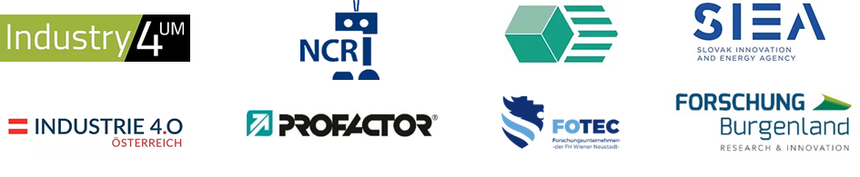

Use Case 1
TITEL OF THE USE CASE: | rob@work

TOPIC: | Sustainable, resillient production systems

CONTACT INFORMATION
Partner organisation: | Fraunhofer-Institut für Produktionstechnik und Automatisierung IPA
Contact person: | Kevin Bregler
Address: | Nobelstr. 12  70569 Stuttgart
E-mail: | kevin.bregler@ipa.fraunhofer.de
Phone: | +49 711 970-1371

DESCRIPTION
Short summary of the Use Case:  Max.200 characters as promotional introduction | In the ATLAS project, Fraunhofer IPA has developed software components with which mobile assistance systems can be used in industrial environments, e.g. for monitoring or surveillance tasks.  By integrating ROS (Robot Operating System) and the OPC Unified Architecture communication protocol, a quasi-standard in mobile robotics was combined with a standard in automation technology. This enables simple but secure inter-process communication for teleoperation of mobile robots via the Internet. 3D environment models visualize for the person operating the assistance system even areas that he cannot currently see himself. Thanks to this telepresence solution, the person can look after the plant as if he or she were there.  The project was funded by the Landesstiftung Baden-Württemberg foundation. Fraunhofer IPA's project partner was the Institute for Process Control (IPR) at the Karlsruhe Institute of Technology (KIT).
Detailed information on the Use Case:  Max.1000 characters about technical features – easy language | rob@work is the prototype of an intelligent assistant system for supporting workers in production environments. The control software of the third rob@work generation is based on field-proven Care-O-bot technologies and experience gained from the operation of the predecessor models rob@work 1 and rob@work 2. rob@work 3 combines an omnidirectional mobile platform and a modular manipulator system to form a fully integrated robot that can be used effectively and flexibly in production.  The high degree of integration of the platform and the availability of various basic functionalities significantly reduce the effort required to implement industrial service robot applications. At the same time, newly developed functionalities can be easily tested in the overall context of the robot application. In addition, the use of a standardized robot platform allows new applications to be implemented and validated more quickly and efficiently. The integration of state-of-the-art technologies enables continuous further development of the system.
Key achievements:  Results of the application for SME e.g. new market entry | rob@work 3 already integrates many basic functionalities of mobile manipulation systems:  - Navigation with natural landmarks, also with simultaneous mapping  - Manipulator control with Cartesian methods as well as interfaces to various path planning algorithms  - Usability of 3D data from stereo vision systems and 3D cameras (e.g. integrated in navigation procedures)  - Object recognition methods
Further information:  Link to further information on the case study can be found | +Fraunhofer IPA - Wir produzieren Zukunft - Fraunhofer IPA
Keywords related to your case study:
Visual presentation:  Image (2000px wide recommended) and/or videeo | 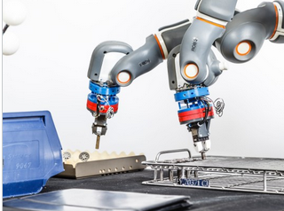
Resources needed:
Please specify the human resources required to set up and to run the case study. Do you need any external experiences to implement the case study? If yes, please specify.

